First Nation – Municipal Community Infrastructure Partnership Program

Exercise: Your Shared History

First Nations and municipalities are not always aware of each other’s history. The purpose of this exercise is to share and explore First Nation and municipal histories for better understanding. Knowing where we came from can sometimes help us know where we want to go.
For this exercise you will need large sticky notes or scrap paper and tape and a large blank wall. It will take about one and a half or two hours to complete this exercise depending on how much time it takes to complete the time line and hold a discussion on the results.
The First Nation and municipal begin this exercise by working in separate groups. Once each community has identified and written each historic event on separate sticky notes or paper, hang the notes on the blank wall starting with the oldest event and each subsequent event following that up to the present. Both the First Nation and the municipality use the same wall space to hang their notes. Post each event in its historical order. If two things happened at roughly the same time post them one above the other. The following photos show the construction of a time line.
Time to complete: 45 min – 90 min
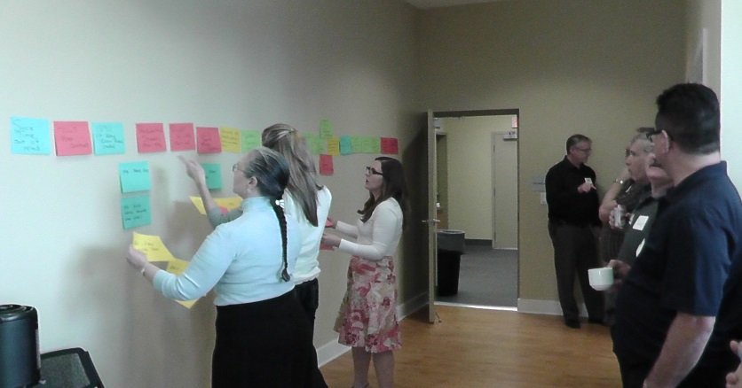

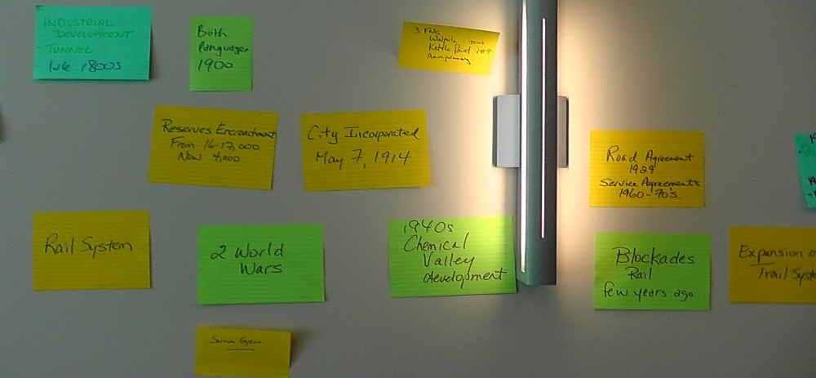

Step 1
Record one significant historic event and the date of that event per page. You may wish to include treaties, municipal incorporation, significant social events, any major disasters in the region, dates of service agreements, etc.

Step 2
Once the First Nation and Municipal groups have completed their record of historic events and added them to the historical time line on the wall, someone from each community explains each event and why they are important to the community.

Step 3
Discuss what you have learned together. Ask questions for further clarification. Explore the implications of these events on your relationship moving forward. Identify new joint events that your communities wish you could add to the timeline in the future.

