First Nation – Municipal Community Infrastructure Partnership Program

Self-Assessment Exercise: Relationship

The purpose of this exercise is to better understand how your partner community views your relationship and understanding of your history, culture and governance practices. By first exploring in your separate communities what you each know about the other and how you feel about the relationship and then sharing your thoughts with your partner community you can jointly explore knowledge gaps and issues that will foster the growth of a positive relationship.

Step 1
Start by creating a graph. Draw a cross in the middle of the page and label each arm of the cross as relationship, history, culture, or governance. Mark zero to ten on each arm of the cross with zero starting at the centre point and ten at the outside end point of the arm of the cross. See the picture below.

Step 2
Next, in your separate communities review the questions below and rate yourselves on your level of knowledge on a scale of one to ten (one being low and 10 being high). This is a group score, so if everyone in your group knows about something rate yourself high on that point but if only one or two people know about something rate yourselves lower. The points under each question are intended to help prompt discussion and help explain the main question. They do not have to be answered individually. Record your answers on the chart. At the end of this exercise share your responses with your partner community and discuss.

Sample charts

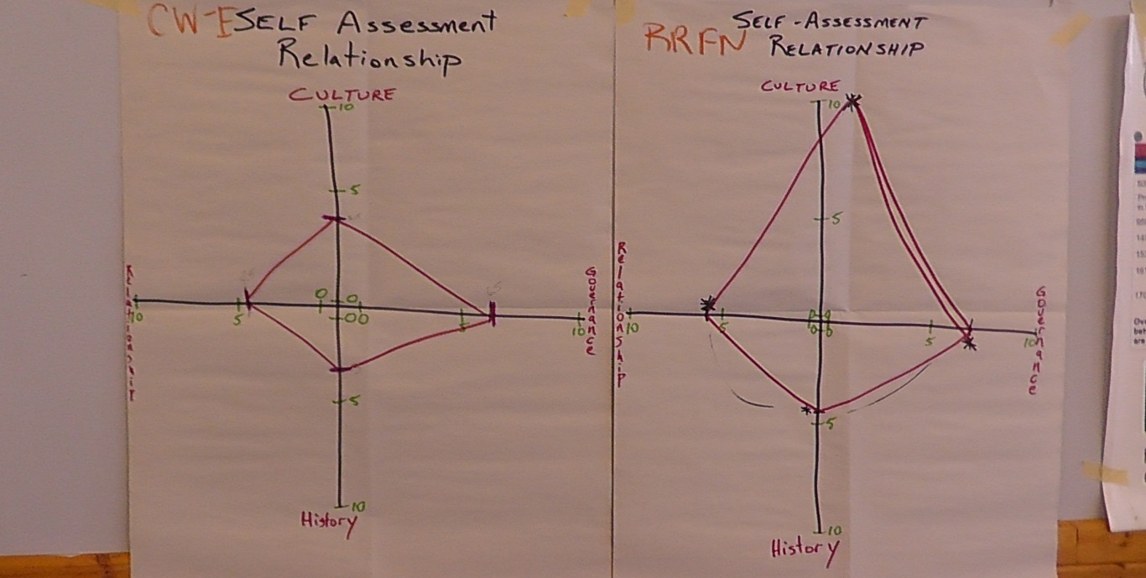
- How well you do you know your partner’s culture and cultural practices?
For example, do you know:
  - the language
  - the traditional foods and drinks
  - how life events are recognized and celebrated (i.e. marriage, birth of child, death),
  - what is sacred or taboo?

- How well do you know your partner community’s laws, government structure, and decision making process?
For example, do you know:
  - Where does your partner community gets its authority to govern?
  - Where does your partner community get its financial resources?
  - Do community members in your partner community have a role in decision making and if yes, what is that role?
  - What subjects can your partner community make laws about or what areas of jurisdiction do they have?
  - What is the relationship of the government of your partner community to other levels of government?

- What is the strength of your relationship with your partner community?
(For this question 1 means a very poor relationship, 10 means a very good relationship.) For example:
  - Have you attended a meeting of your partner’s council?
  - Does your political leadership meet regularly with your partnering community’s leadership?
  - Do your communities participate in social or civic events together (i.e. hockey games, community groups, church, school, etc)?
  - Do your citizens feel welcome and safe in your partner community?

- How well do you know the history of your partner community?
  - Do you know when the municipality was incorporated or when the band was established?
  - How much do you know about historical events within your partner community (i.e., signing of treaty, opening and/or closure of major businesses or industries, when a school, recreation centre, or hospital opened or closed)?
  - How much do you know about important historical figures from your partner community?

Step 3
Discuss the results between your communities. Share information, explore issues, identify ways to move forward together.

